MFANZ Interface Control System:

Disaster Recovery

Last Saved: 6/05/2009 01:57:00 AM

Table Of Contents
1 Table Of Contents 2
2 Document Purpose 3
3 Definitions 3
4 Background 3
5 Component Installation 3
5.1 Unix Scripts 3
5.1.1 Configuration 3
5.1.2 Directory Structure 4
5.1.3 Script and Configuration files 4
5.1.4 AMI Configuration 5
5.2 Database 5
5.3 Webpage 5
5.3.1 Dynamic Link Libraries (DLLs) 6
6 Appendix 7
6.1 Example Work Orders 7
6.1.1 ICS Webpage 7

Document Purpose

Provide a step-by-step guide to managing disaster recovery on a Unix or Linux server that has ICS installed. This is assuming the recovery is taking place on a new server, or the server ICS was installed on has been rebuilt. Refer to the 5.3 Webpage for information on how to manage disaster recovery for a virtual machine running an ICS webpage. The loss of the ICS webpage is not a critical issue, as the interfaces and jobs will still run as normal, and can be manually managed through the database. The loss of a Unix/Linux server is a critical issue as the database itself will not be available, nor will any files be able to be sent to the server.

Definitions

Name | Definition
PTR | Path To Repository – the local path on your computer to the TortoiseSVN repository. Eg: c:\work
ICS | Interface Control System
LICS | Local Interface Control System
SYSTEM | The system name in question. Eg CDW, EFEX, PLANT, etc

Background

Disaster recovery is an important part of any business. The ICS system is a critical component for a number of different systems across the AP region. It encapsulates the complexity of loading data sent via the AMI infrastructure, along with displaying support related monitoring and logging information. ICS is built from a number of different components that allow it to carry out the tasks it has been designed for. These components include database components, webpage components and also Unix/Linux components.

Component Installation

Unix Scripts

The Unix scripts are responsible for managing inbound/outbound transfers and other functionality (purging, loading files to view via the webpage, etc). The script to use can be defined in the interface configuration on the ICS webpage. The transfer type (MQFT, DJ, etc) will decide which script to use for an interface.

Configuration

If the server ICS is being installed onto does not have a previous installation of ICS on it, you will need to setup the ICS user account and file system. A work order will need to be created to get the ICS user and file system added to the system, and it is always good to include a similar system with ICS installed already as a template. So the configuration should include:

- Creation of an ICS user (ITSA - #ISA76H937v1)
- Creation of an ICS file system
- Add the ICS user to the MQM group
- Ensure the Oracle user is also part of the MQM group

The WO should be forwarded to the UNIX magic group.

Directory Structure

The directory structure is similar for each ICS installation. You can use the ics_create_fs.sh script to generate the required directory structure. The script takes the following parameters:

Root Directory – the root directory of the ICS file system. Defaults to /ics (if using *NONE).
System – the name of the system ICS is running for. Defaults to LADS (if using *NONE).
Environment – the type of environment ICS is running under. Use either test or prod.

The script will not attempt to create a directory if it already exists. For example:

./ics_create_fs.sh *NONE lad test

The script will also set the correct permissions, and create the integration log file where all logging is stored for ICS scripts. If there are any issues running the script, you can manually create the structure as defined below:

Create a new directory in the ics root (such as lad), and then create another directory based on the environment (test or prod). The following directories should then be added:

- archive – processed inbound/outbound files
- bin – scripts for processing inbound and outbound interfaces
- config – configuration files for the environment the interfaces are being processed for
- inbound – inbound files to be processed
- java – directory used by Oracle
- log – log files for the current day
- outbound – outbound files to be processed
- statistics – directory used by Oracle
- temp – folder for placing temp files. Not used by scripts, but can be useful for testing/debugging purposes
- webview – temporary location for files being viewed through the ICS webpage
- work – temporary location for files being used by an interface being processed
- log/archive – archive of log files from previous days

Script and Configuration files

The script files are standard across all ICS installations. They are located in the following directory:

<PTR>\Regional\SOURCE\LICS\BASE\UNIX

Copy all files from that directory in the bin directory on the server.

The configuration file, ics_loader.config, is unique for each environment. Browse to the bespoke folder for the system (located in <PTR>\Regional\SOURCE\LICS\BESPOKE\) and copy the file into the config directory. If there are other files in the systems bespoke directory, ensure they are uploaded also. This might cover trigger files for MQIF and DJ inbound transfers.

AMI Configuration

The AMI environment will also need to be configured. Once the AMI environment is available on the server, you will need to provide the AMI team with a list of the interfaces so they can set the trigger information in the jobs.conf.xml file. That file is used for MQFT transfers only. You can use the New Interface Request Template.xls file in the <PTR>\Regional\DOCUMENTATION\TEMPLATE folder to add all the information the AMI team will require. Raise a WO to get the changes implemented.

If the system uses MQIF or DJ for data transfers, there should be a trigger file in the configuration directory that stores bespoke data for the system. This should have already been updated in step 5.1.3. Refer to that section for more information.

Database

During a disaster recovery, the DBA’s should be able to restore the database as it was before. However, if the database has been added to a new server, you will need to rerun the database setup script to enable the database to communicate with the server it is on. The parameter file (lics_parameter.sql) will also need to be checked to ensure it reflects any changes to the location of the files or the webpage.

The following work needs to be done:

- Create a WO to the DBA’s to run the ics_database_setup.sql script in the <PTR>\SOURCE\LICS\BASE\ORACLE\INSTALL directory.
- Update the lics_parameter package with the correct information and run on LICS_APP

Webpage

The ICS webpage is located on virtual machines (APVN22 for example). If the virtual server crashes, the ICS webpage will need to be re-created on a new server. Use the files from the <PTR>\SOURCE\LICS\BASE\MICROSOFT\ASP directory and then overwrite them with any files in the bespoke folder for the given system (<PTR>\ SOURCE\LICS\BESPOKE\<SYSTEM>\MICROSOFT\ASP). Send those files to the WEB_INFRASTRUCTURE team for them to add to the new system.

Note, if the new virtual machine has not had ICS run on it before, carry out the steps in 5.3.1.

Dynamic Link Libraries (DLLs)

The DLLs are only required if the web server does not already have an existing ICS installation. Create a WO to get the DLLs registered on the web server, and forward it to the WEB_INFRASTRUCTURE team. The DLLs are located in the following directory:

<PTR>\Regional\SOURCE\LICS\BASE\MICROSOFT\VB\bin

Once the DLLs have been registered you can install the ICS webpage.

Appendix

Example Work Orders

ICS Webpage

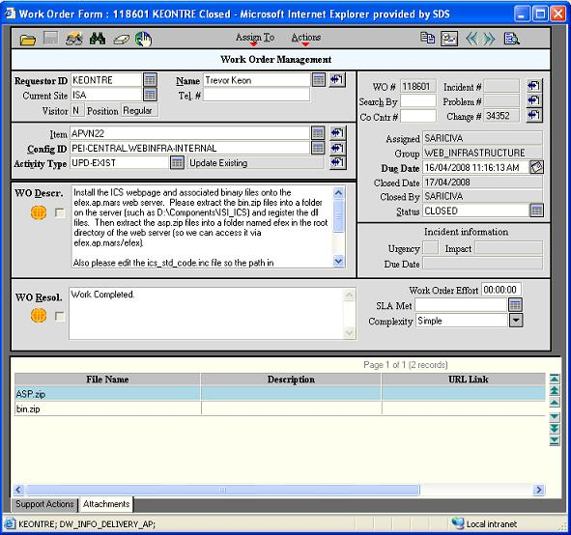

The WO Description is as follows:

Install the ICS webpage and associated binary files onto the efex.ap.mars web server. Please extract the bin.zip files into a folder on the server (such as D:\Components\ISI_ICS) and register the dll files. Then extract the asp.zip files into a folder named efex in the root directory of the web server (so we can access it via efex.ap.mars/efex).

Also please edit the ics_std_code.inc file so the path in the "GetSecurityCheck" function is set correctly for the ics_security.txt file.

I have run through a similar install with Ivan Saric on webappdev51.ap.mars, so contact him for any questions.

For plant databases, the system is not specified. Use *EXCLUDE to prevent creating a system directory.
Appendix 6.1.3 – ICS Webpage

